**Text**

create table Text(Text_ID int, Text_Format varchar(1000) , primary key(Text_ID));

// create table Text(Text_ID int, Text_Format varchar(1000) , primary key(Text_ID) ,foreign key (Text_ID) REFERENCES Multimedia_Repository(ContentId)));

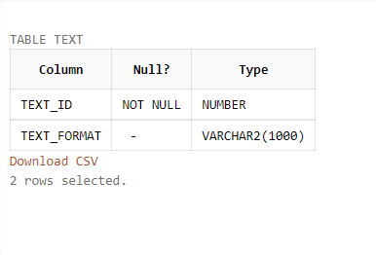

insert into Text values(1001,'.DOC');

insert into Text values(1058,'.TEXT');

insert into Text values(1136,'.DOCX');

insert into Text values(1379,'.WRI');

insert into Text values(1678,'.DOC');

insert into Text values(1734,'.LATEX');

select *from Text;

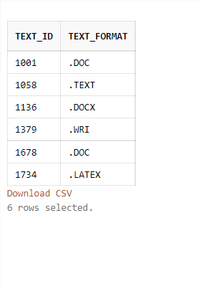

**Video**

create table Video(Video_ID int, Video_Format varchar(1000) , primary key(Video_ID));

// create table Video(Video_ID int, Video_Format varchar(1000) , primary key(Video_ID), foreign key (Video_ID) REFERENCES MultimediaRepository(ContentId)));

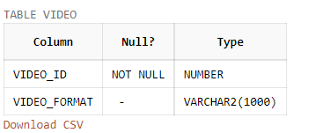

insert into Video values(2007,'.MPEG');

insert into Video values(2091,'.MPV');

insert into Video values(2373,'.MP4');

insert into Video values(2555,'.M4V');

insert into Video values(2768,'.AVI');

insert into Video values(2877,'.MP4');

select *from Video;

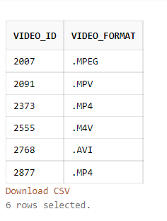

**Image**

create table Image(Image_ID int, Image_Format varchar(1000) , primary key(Image_ID));

// create table Image(Image_ID int, Image_Format varchar(1000) , primary key(Image_ID), foreign key (Image_ID) REFERENCES MultimediaRepository(ContentId)));

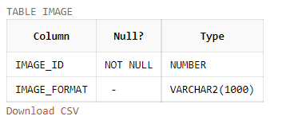

insert into Image values(3347,'.MPEG');

insert into Image values(3431,'.MPV');

insert into Image values(3343,'.MP4');

insert into Image values(3465,'.M4V');

insert into Image values(3756,'.AVI');

insert into Image values(3907,'.MP4');

select *from Image;

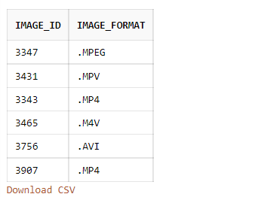

**Audio**

create table Audio(Audio_ID int, Audio_Format varchar(1000) , primary key(Audio_ID));

// create table Audio(Audio_ID int, Audio_Format varchar(1000) , primary key(Audio_ID), foreign key (Audio_ID) REFERENCES MultimediaRepository(ContentId)));

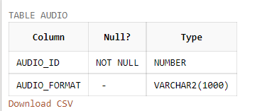

insert into Audio values(4005,'.M4A');

insert into Audio values(4893,'.FLAC');

insert into Audio values(4219,'.MP3');

insert into Audio values(4666,'.WAV');

insert into Audio values(4524,null);

insert into Audio values(4773,'.MP4');

select *from Audio;

